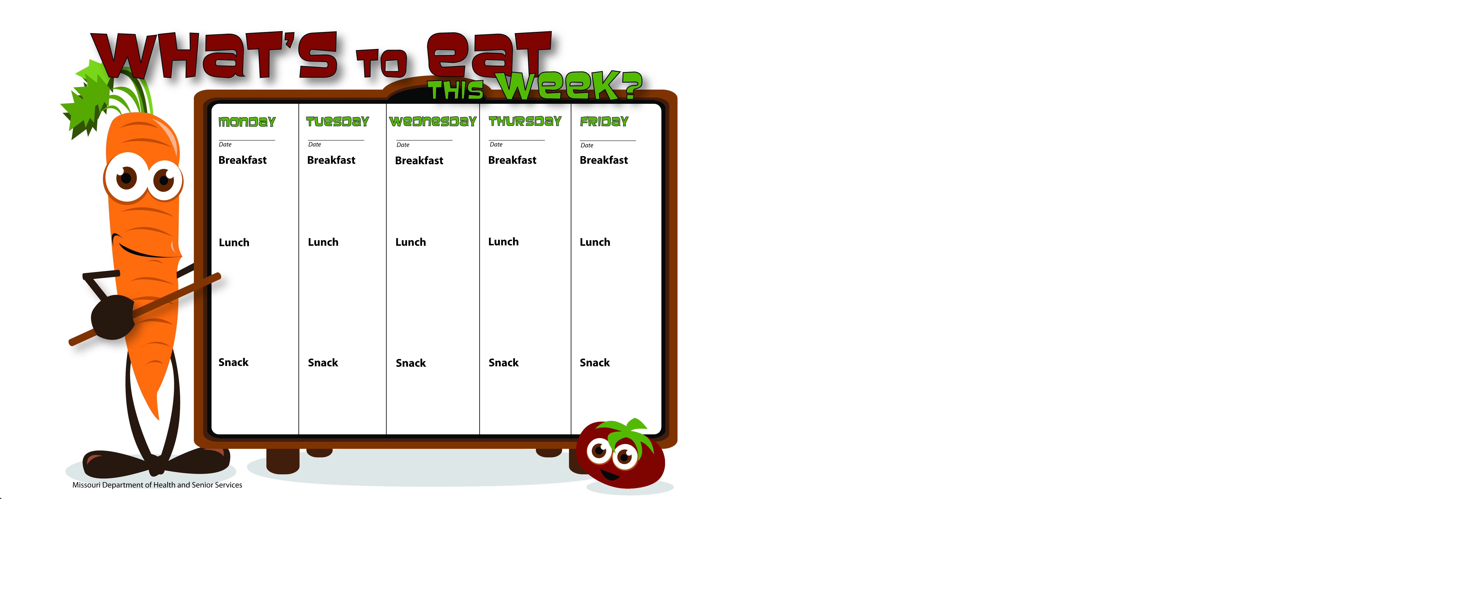

10/27/14

10/28/14

10/31/14

10/30/14

10/29/14

Graham Crackers

String Cheese

Water

WG Cheerios

Skim Milk

Chicken Broccoli Fettuccini

Garden Salad W/Ranch

Orange Slices

Skim Milk

Oatmeal

Orange Slices

Skim Milk

WG Honey Kix

Bananas

Skim Milk

Blueberry Muffins

Peaches

Skim Milk

French Toast Stx.

Applesauce

Skim Milk

WG Bagel Thin

Peanut Butter

Skim Milk

WG Ham and Spinach Wrap

Green Beans

Apples & Bananas

Skim Milk

Mostaccioli W/Ground Turkey

WG Bread

Peas

Pears

Skim Milk

Taco Soup W/Ground Beef

Tomatoes

Tortilla Chips

Orange Slices

Skim Milk

WG Chicken Veggie Pizza

Mixed Vegetables

Mandarin Oranges

Skim Milk

Carrot Stix

Ranch Dip

Skim Milk

Fruit Salad

Skim Milk

Wheat Crackers

Peanut Butter

Water