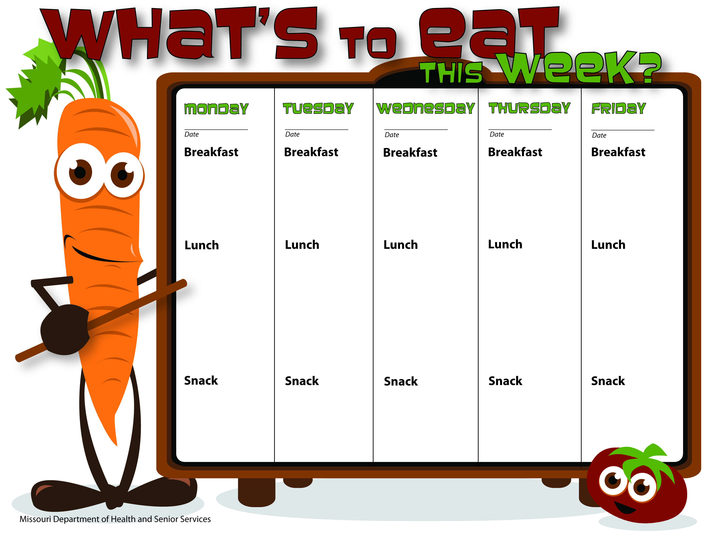
12-1-21
11-30-21
11-29-21
12-2-21
12-3-21
WG Cheerios
Orange Slices
Skim Milk
WG Pancakes
Applesauce
Skim Milk
Oatmeal
Raisins
Skim Milk
WG Bagels
Cream Cheese
Apples
Sunflower Butter
Skim Milk
Biscuits & Gravy
Peaches
Skim Milk
WG Pepperoni Pizza
Carrots W/Ranch Dip
Oranges
Skim Milk
Spanish Rice W/GB
Corn
Peaches
Skim Milk
Baked Ham
Green Beans
Roll
Mixed Fruit
Skim Milk
WG Hot Ham & Cheese Wraps
Baked French Fries W/Ketchup
Strawberries
Skim Milk
String Cheese
Wheat Crackers
Skim Milk
Graham Crackers
Yogurt
Water
Bananas
Skim Milk
Granola Bars
Raisins
Skim Milk
WG Trail Mix
Dried Fruit
Skim Milk
Turkey Tetrazzini
Peas
Bananas
Skim Milk

