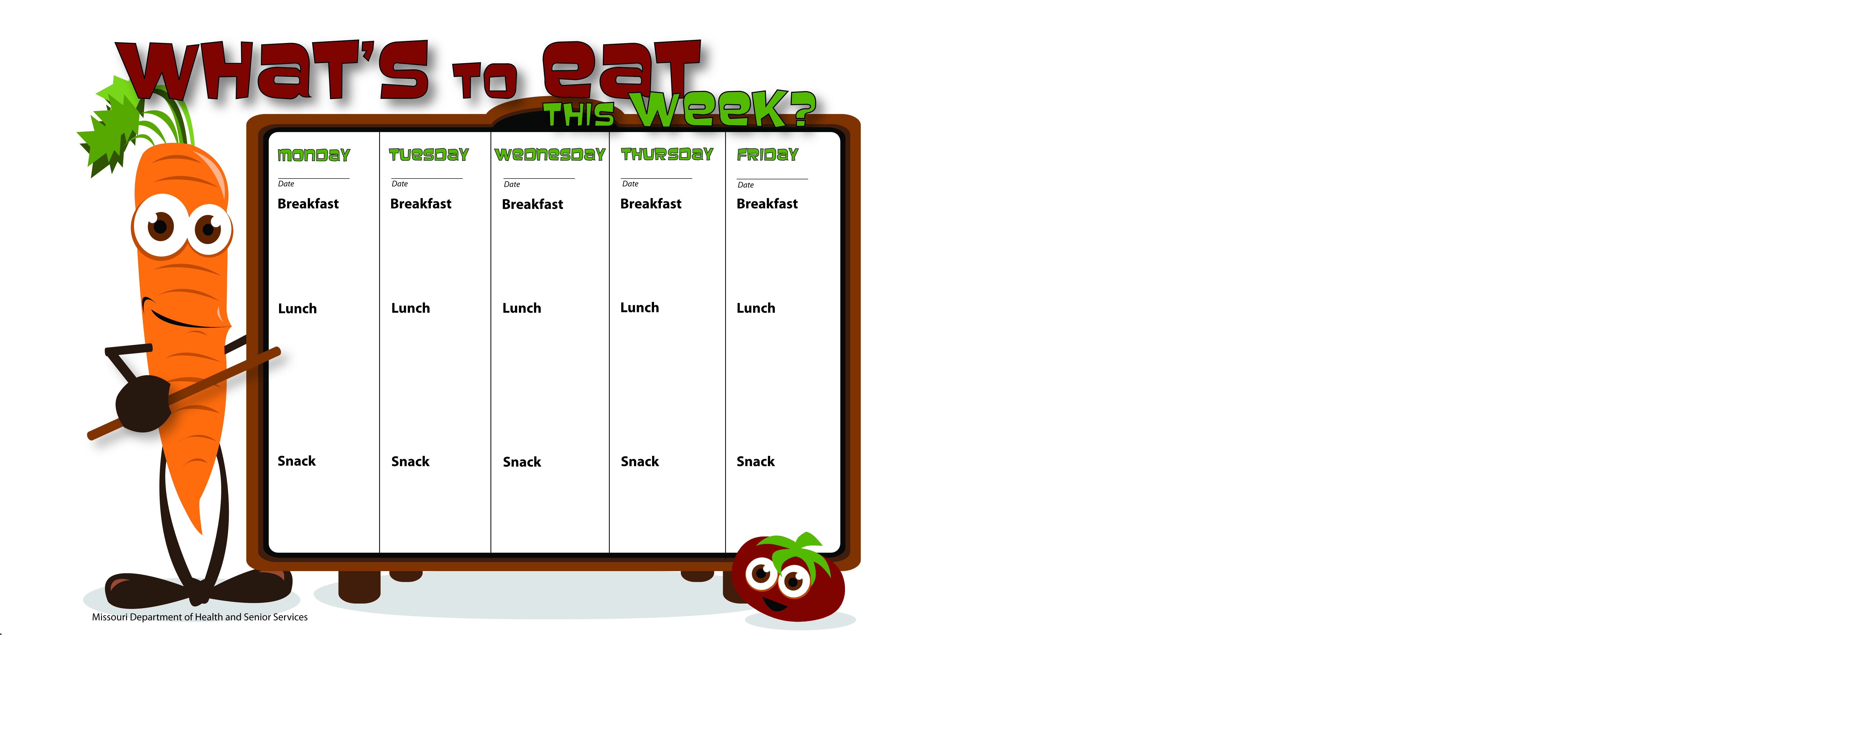

3/30/15

3/31/15

4/3/15

4/2/15

4/1/15

Animal Crackers

Peanut Butter

Skim Milk

Watermelon

Skim Milk

WG Pepperoni Pizza Wraps

Green Beans

Orange Slices

Skim Milk

WG Cinnamon Toast

Orange Slices

Skim Milk

Cream of Wheat

Raisins

Skim Milk

Scrambled Eggs

Whole Wheat Toast

Orange Slices

Skim Milk

Biscuits & Gravy

Peaches

Skim Milk

WG Bagel Thins

W/Cream Cheese

Pineapple Tidbits

Skim Milk

Porcupine Sliders

Cooked Carrots

Fruit Salad

Whole Wheat Bread

Skim Milk

Bowtie Pasta W/Zucchini

Bananas

Peas

Skim Milk

WG Grilled Cheese Sandwich

Pea Salad

Apple Slices

Skim Milk

WG Beef & Noodles

Corn

Mandarin Oranges

Skim Milk

Pretzel Stx

Peanut Butter

Water

Vanilla Yogurt

Strawberries

Water

WG Peanut Butter & Jelly Sandwich

Skim Milk