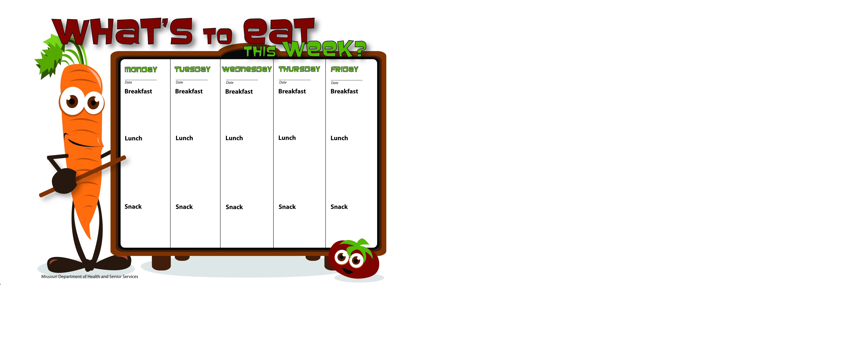

4-25-16

4-26-16

4-29-16

4-28-16

4-27-16

Trail Mix

Raisins

Skim Milk

Applesauce

Skim Milk

Chicken Ratatouille W/WG Noodles

Green Beans

Mandarin Oranges

Skim Milk

Pancakes

Applesauce

Skim Milk

WG Honey Kix

Bananas

Skim Milk

WG Oatmeal

Cantaloupe

Skim Milk

Cheesy Scrambled Eggs

Whole Wheat Toast

Orange Slices

Skim Milk

Biscuits & Gravy

Peaches

Skim Milk

Sloppy Joe W/GB on Whole Wheat Bun

Baby Carrots W/Ranch Dip

Fruit Salad

Skim Milk

Porcupine Sliders

Cooked Carrots

Fruit Salad

Whole Wheat Bread

Skim Milk

Taco Salad W/Greens, Ground Beef

Tortilla Chips

Tropical Fruit Salad

Skim Milk

WG Mexican Pizza

Mixed Vegetables

Pineapple Tidbits

Skim Milk

Wheat Crackers

Cheese

Water

WG Peanut Butter & Jelly Wrap

Banana

Skim Milk

Apples

Peanut Butter

Water