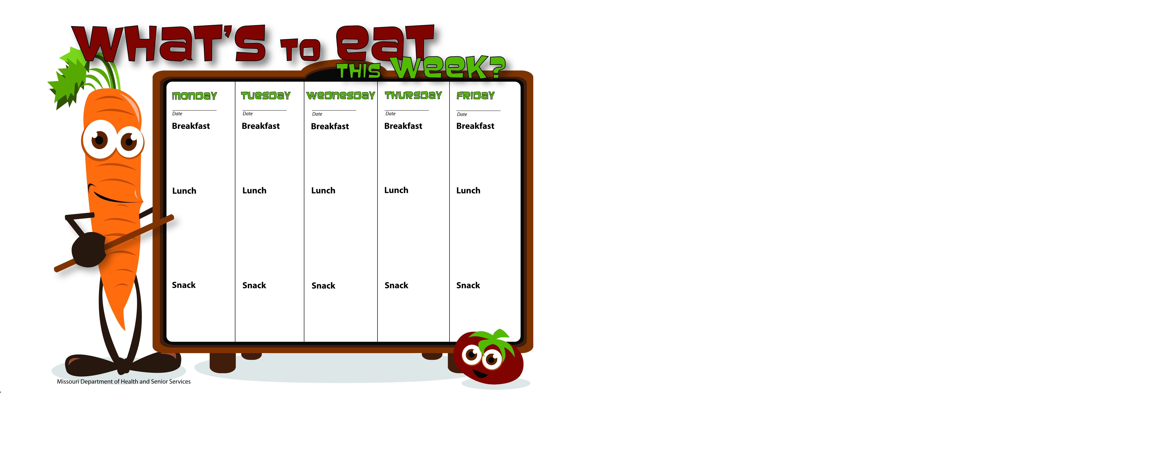

4/20/15

4/21/15

4/24/15

4/23/15

4/22/15

Granola Bars

Skim Milk

Bananas

Skim Milk

Spanish Rice

Peas

Apple Slices

Skim Milk

Pancakes

Applesauce

Skim Milk

WG Oatmeal

Raisins

Skim Milk

Whole Wheat Bagel Thin W/Cream Cheese

Peaches

Skim Milk

WG PB Apple Pocket

Skim Milk

Scrambled Eggs

Whole Wheat Toast

Orange Slices

Skim Milk

WG Soft Tacos

Lettuce,Tomato

Green Beans

Bananas

Skim Milk

WG Turkey Pepperoni Pizza Pockets

Spinach Salad

Orange Slices

Skim Milk

WG Spaghetti W/Ground Beef

Corn

Mandarin Oranges

Skim Milk

WG Chicken Mini Pizza

Mixed Vegetables

Pineapple Tidbits

Skim Milk

WG Peanut Butter Sandwich

Applesauce

Skim Milk

String Cheese

Apple Slices

Water