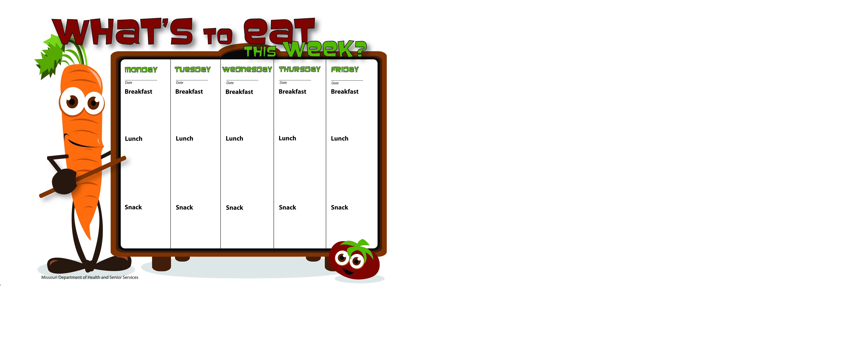

3/23/15

3/24/15

3/27/15

3/26/15

3/25/15

Graham Crackers

Vanilla Yogurt

Water

String Cheese

Wheat Crackers

Water

WG Chicken Salad Wrap

Carrots

Apple Slices

Skim Milk

WG Oatmeal

Raisins

Skim Milk

Scrambled Eggs

Whole Wheat Toast

Orange Slices

Skim Milk

WG Bagel W/Cream Cheese

Apricots

Skim Milk

Biscuits & Gravy

Peaches

Skim Milk

Pancakes

Applesauce

Skim Milk

WG Mini Turkey Pepperoni Pizza

Green Beans

Pineapple Tidbits

Skim Milk

WG Spaghetti W/Ground Beef

Corn

Mandarin Oranges

Skim Milk

WG Sloppy Joe on Bun

Peas

Fruit Salad

Skim Milk

WG Hot Ham and Cheese Wrap

Mixed Vegetables

Pineapple Tidbits

Skim Milk

Applesauce

Skim Milk

Banana

Skim Milk

WG Peanut Butter Sandwich

Skim Milk