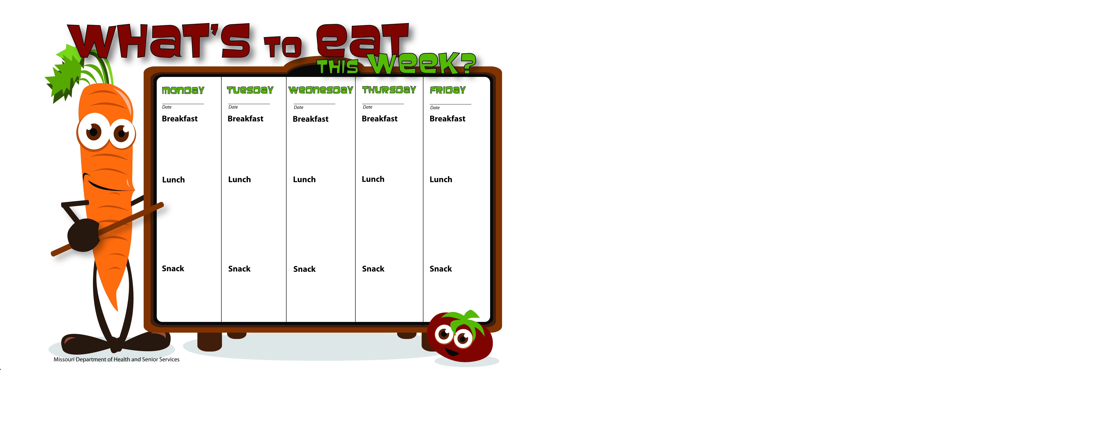

6-23-14

6-24-14

6-27-14

6-26-14

6-25-14

Granola Bars

Skim Milk

Bananas

Skim Milk

WG Spaghetti W/Ground Turkey

Corn

Mandarin Oranges

Skim Milk

Pancakes

Vanilla Yogurt

Pineapples

Skim Milk

WG Cheerios

Bananas

Skim Milk

WG Bagel Thins W/Egg and Cheese

Peaches

Skim Milk

WG Peanut Butter Apple Pockets

Skim Milk

WG Sunshine Taco

Orange Slices

Skim Milk

WG Chicken Alfredo Pizza

Spinach Salad

Pineapple Tidbits

Skim Milk

Taco Salad W/Ground Beef

Lettuce, Tomato

Bananas

Tortilla Chips

Skim Milk

WG Ham & Cream Cheese Tortilla Roll-ups

Mixed Vegetables

Orange Slices

Skim Milk

WG Chicken Salad Wrap

Carrots

Sliced Apples

Skim Milk

Applesauce

Skim Milk

WG Peanut Butter Sandwich

Water

Fruit Salad

Skim Milk