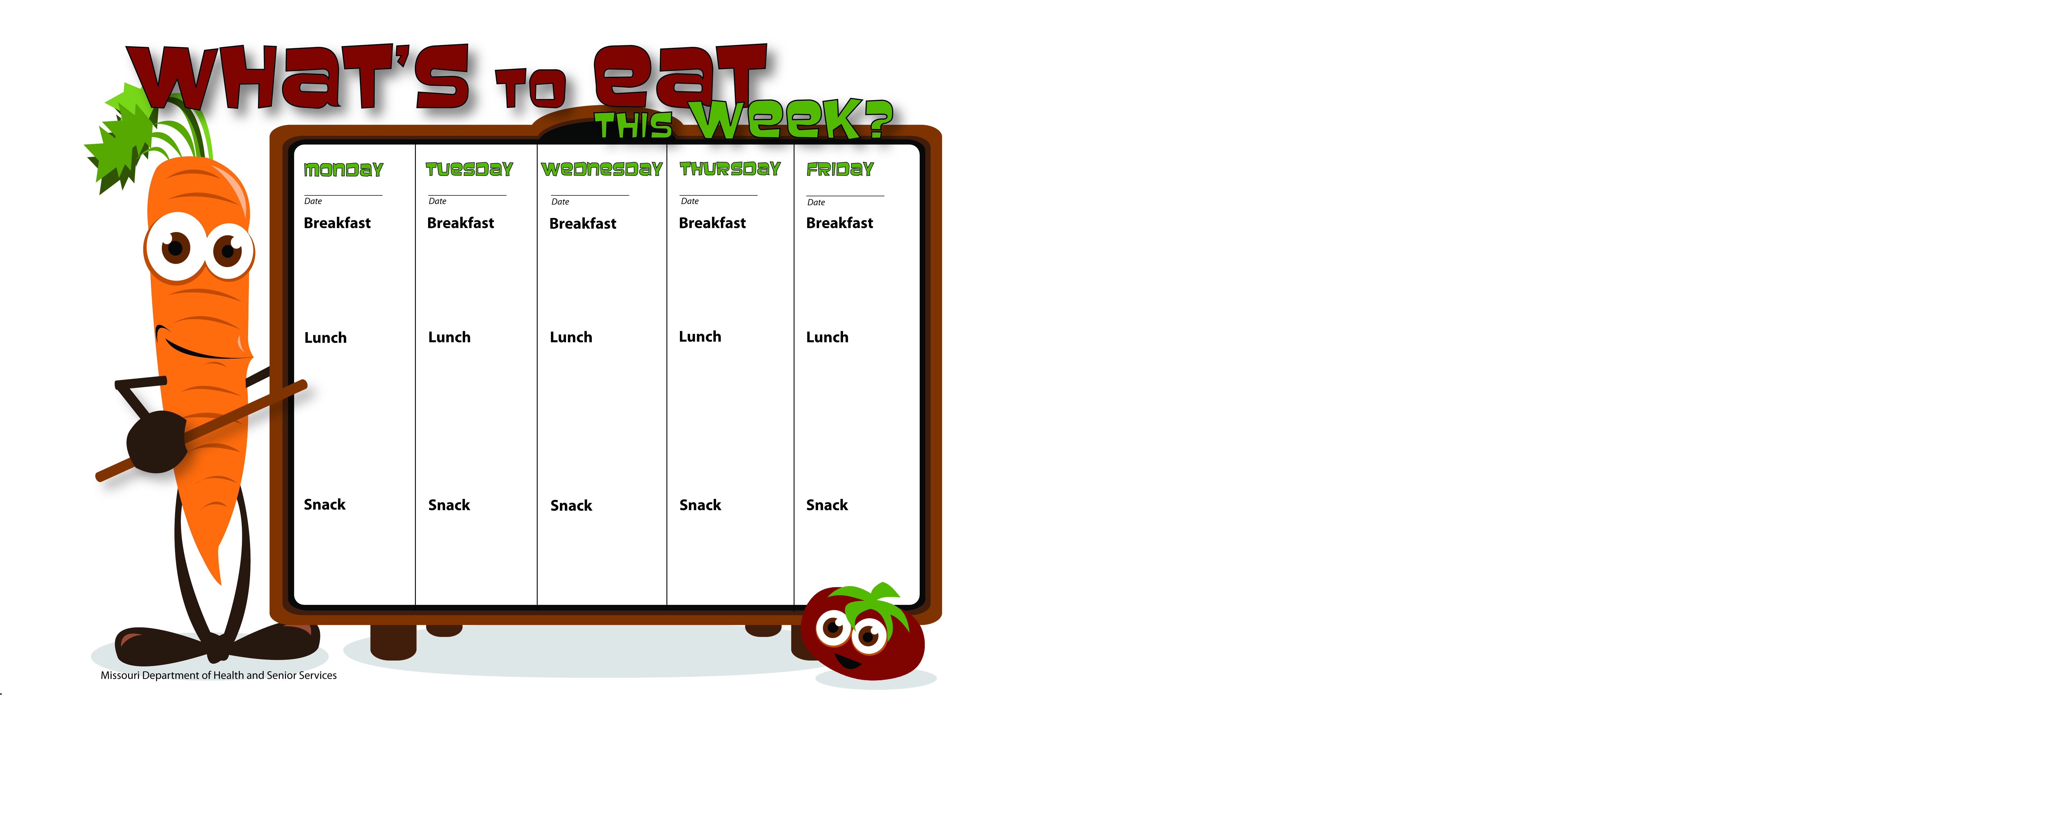

1-26-15

1-27-15

1-30-15

1-29-15

1-28-15

Junior Trail Mix

Raisins

Skim Milk

WG Peanut Butter Banana Pocket

Skim Milk

WG Beef & Bean Burrito

Corn

Tropical Fruit Salad

Skim Milk

Pancakes

Applesauce

Skim Milk

Scrambled Eggs

Whole Wheat Toast

Apple Slices

Skim Milk

Biscuits & Gravy

Peaches

Skim Milk

Vanilla Yogurt

Whole Wheat Toast

Pineapple Tidbits

Skim Milk

WG Mini Breakfast Pizza

Apricots

Skim Milk

Ham and Beans

Cornbread

Orange Slices

Skim Milk

WG Hot Ham and Cheese Wrap

Fresh Carrots

Ranch Dip

Apple Slices

Skim Milk

WG Grilled Cheese Sandwich

Tomato Soup

Crackers

Bananas

Skim Milk

WG Mexican Pizza

Corn

Fruit Salad

Skim Milk

String Cheese

Orange Slices

Water

Pretzel Stx.

Peanut Butter

Water

Cheez Its

Bananas

Skim Milk