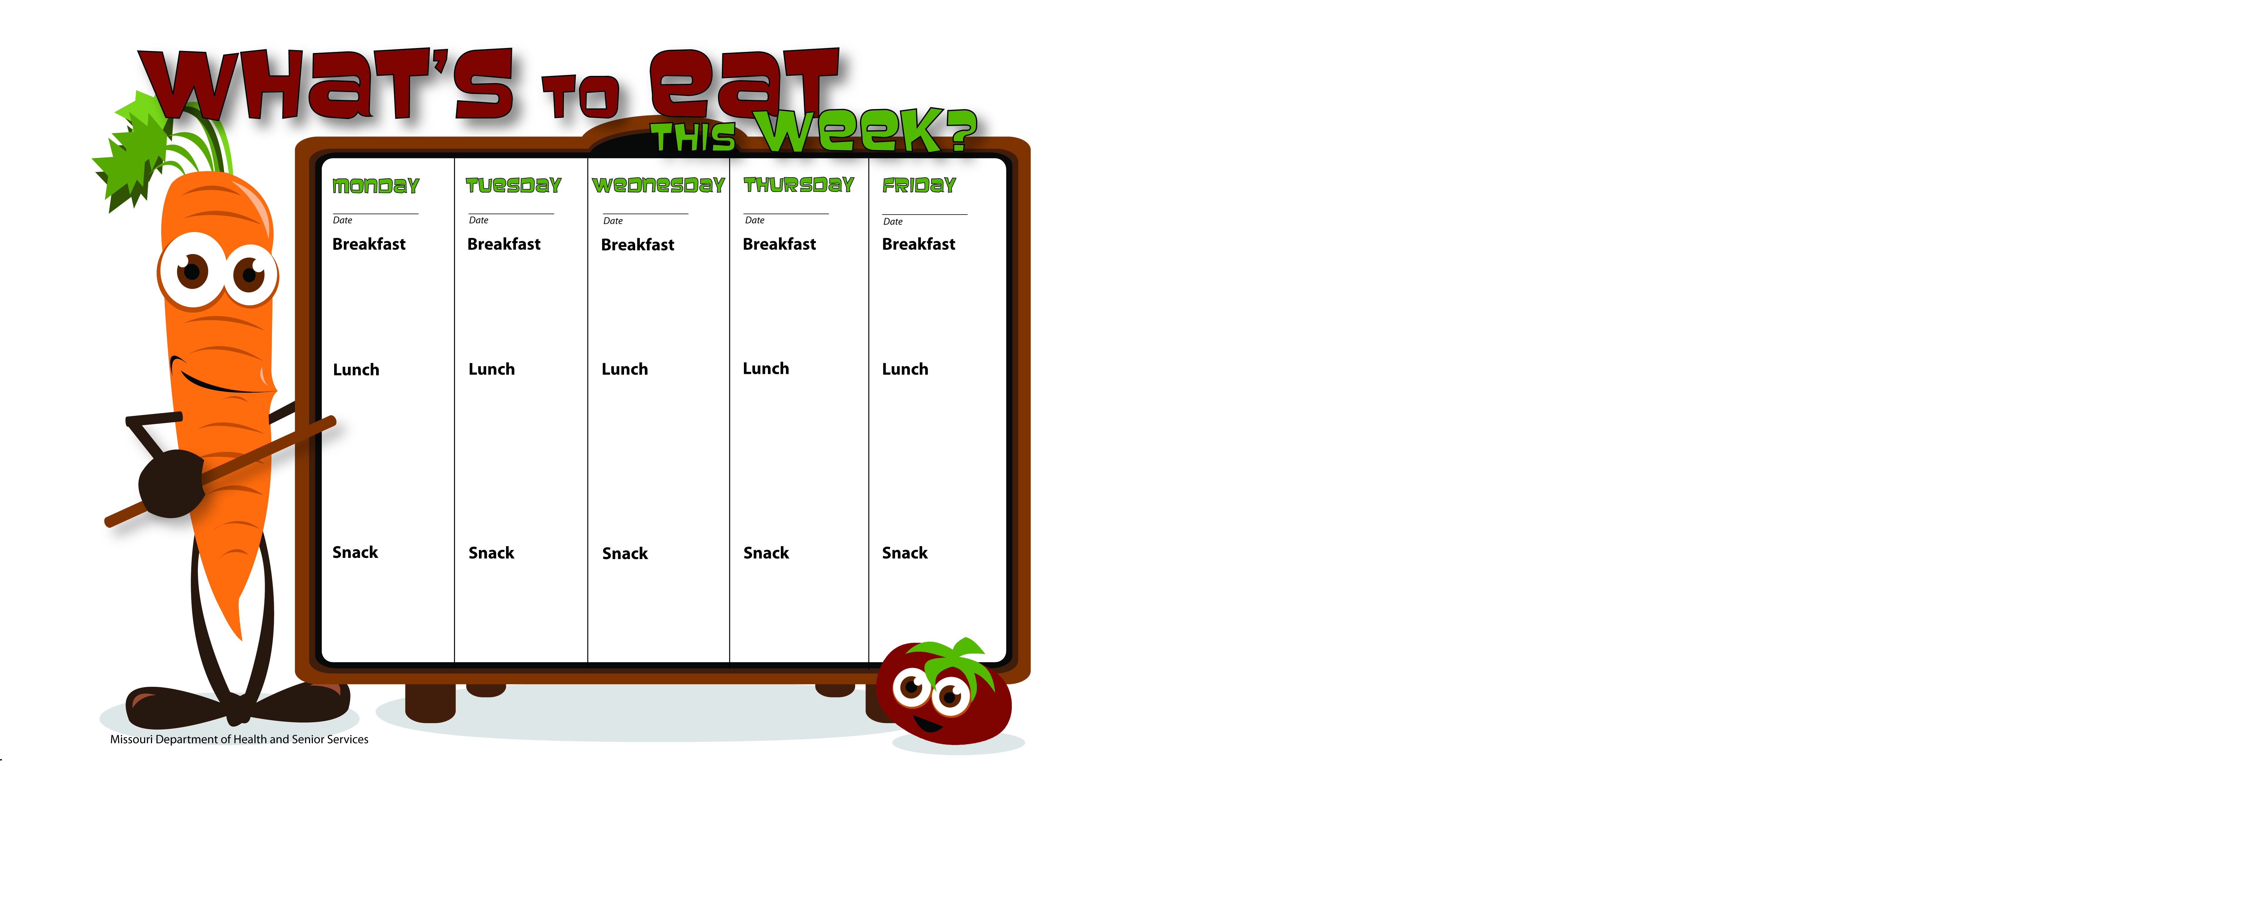

8-18-14

8-19-14

8-22-14

8-21-14

8-20-14

Pretzel Stx.

Peanut Butter

Water

Fruit Salad

Skim Milk

WG Spaghetti W/Ground Beef

Corn

Mandarin Oranges

Skim Milk

WG Cheerios

Orange Slices

Skim Milk

WG Peanut Butter Apple Pocket

Skim Milk

WG Bagel Thin W/Egg and Cheese

Mandarin Oranges

Skim Milk

Biscuits & Gravy

Pears

Skim Milk

WG Sunshine Taco

Orange Slices

Skim Milk

WG Chicken Mini Pizza

Spinach Salad

Pineapple

Skim Milk

Taco Salad

Lettuce, Tomato

Tortilla Chips

Bananas

Skim Milk

Vegetable Soup W/ Ground Turkey

Apple Slices

Crackers

Skim Milk

WG Hot Ham & Cheese Wrap

Green Beans

Pineapple Tidbits

Skim Milk

Applesauce

Skim Milk

Vanilla Yogurt

Pineapple

Water

WG Peanut Butter Sandwich

Skim Milk