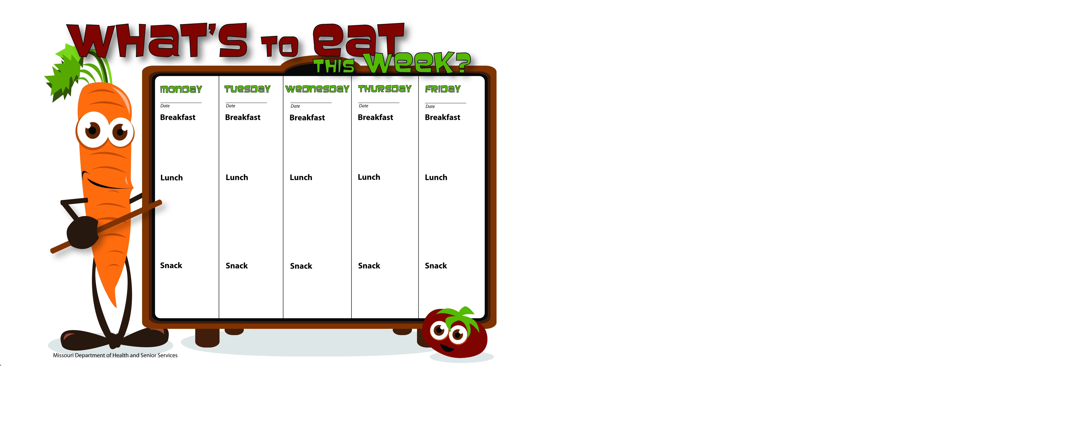

8-7-17

8-8-17

8-11-17

8-10-17

8-9-17

Yogurt W/WG Cheerios

Banana

Water

Fruit Salad

Skim Milk

WG Spaghetti W/GB

Corn

Mandarin Oranges

Skim Milk

WG Kix

Apple Slices

Skim Milk

Whole Wheat Bagel Thin W/Egg & Cheese

Pears

Skim Milk

Biscuits & Gravy

Peaches

Skim Milk

Pancakes

Applesauce

Skim Milk

Scrambled Eggs

Whole Wheat Toast

Mandarin Oranges

Skim Milk

WG Pepperoni Pizza

Baby Carrots W/Ranch

Pineapple Tidbits

Skim Milk

Taco Salad W/GB

Lettuce, Tomato

Tortilla Chips

Orange Slices

Skim Milk

Vegetable Soup W/Ground Beef & Quinoa

Oyster Crackers

Orange Slices

Skim Milk

WG Chicken Alfredo

Peas

Tropical Fruit Salad

Skim Milk

Cinnamon Applesauce

Skim Milk

Bananas

Skim Milk

WG Nut-Free Butter & Apple Wrap

Skim Milk