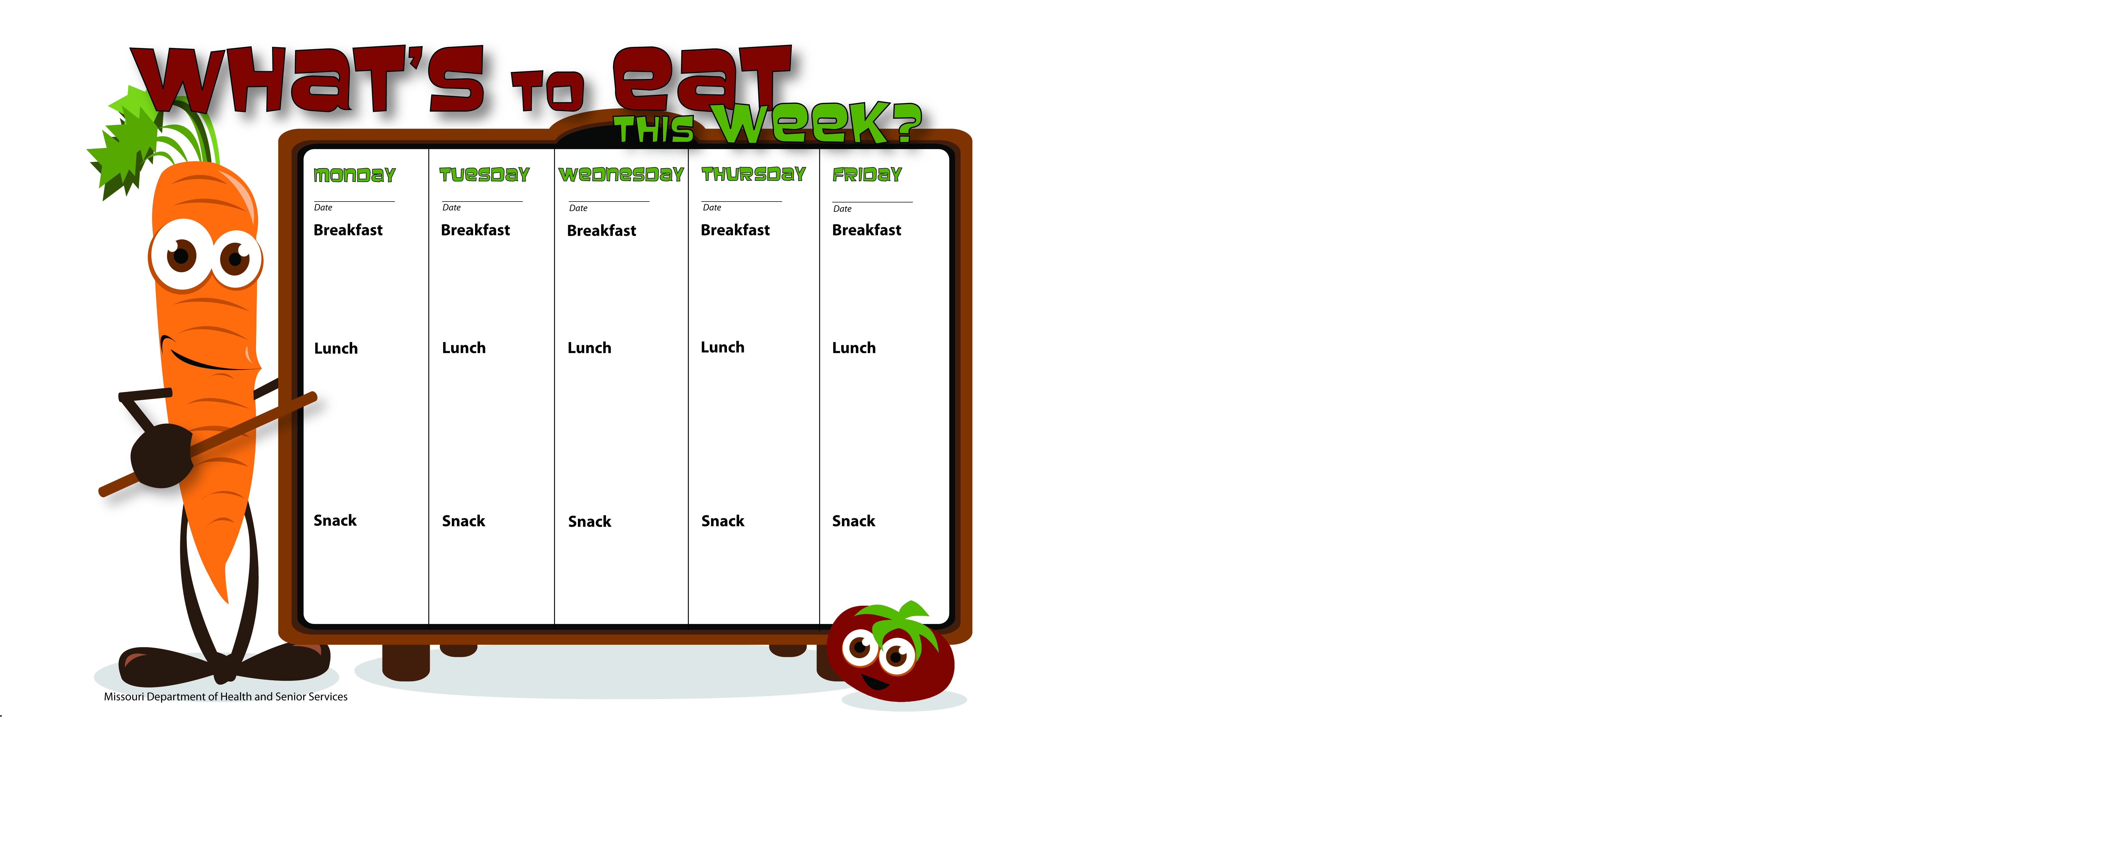

8-15-16

8-16-16

8-19-16

8-18-16

8-17-16

Banana

Skim Milk

Fruit Salad

Skim Milk

WG Spaghetti W/Ground Turkey

Corn

Mandarin Oranges

Skim Milk

WG Kix

Tropical Fruit Salad

Skim Milk

Whole Wheat Bagel Thin W/Egg & Cheese

Mixed Fruit

Skim Milk

Biscuits & Gravy

Peaches

Skim Milk

Scrambled Eggs

Whole Wheat Toast

Mandarin Oranges

Skim Milk

Pancakes

Applesauce

Skim Milk

WG Taco Pizza

W/GB

Spinach Salad

Pineapple Tidbits

Skim Milk

Southwest Salad W/Chicken

Tortilla Chips

Ranch Dressing

Bananas

Skim Milk

Vegetable Soup W/Ground Beef

Oyster Crackers

Orange Slices

Skim Milk

WG Chicken Alfredo

Peas

Apple Slices

Skim Milk

Cinnamon Applesauce

Skim Milk

Vanilla Yogurt

W/WG Cheerios, Granola & Blueberries

Water

WG PB & Banana

Sandwich

Skim Milk