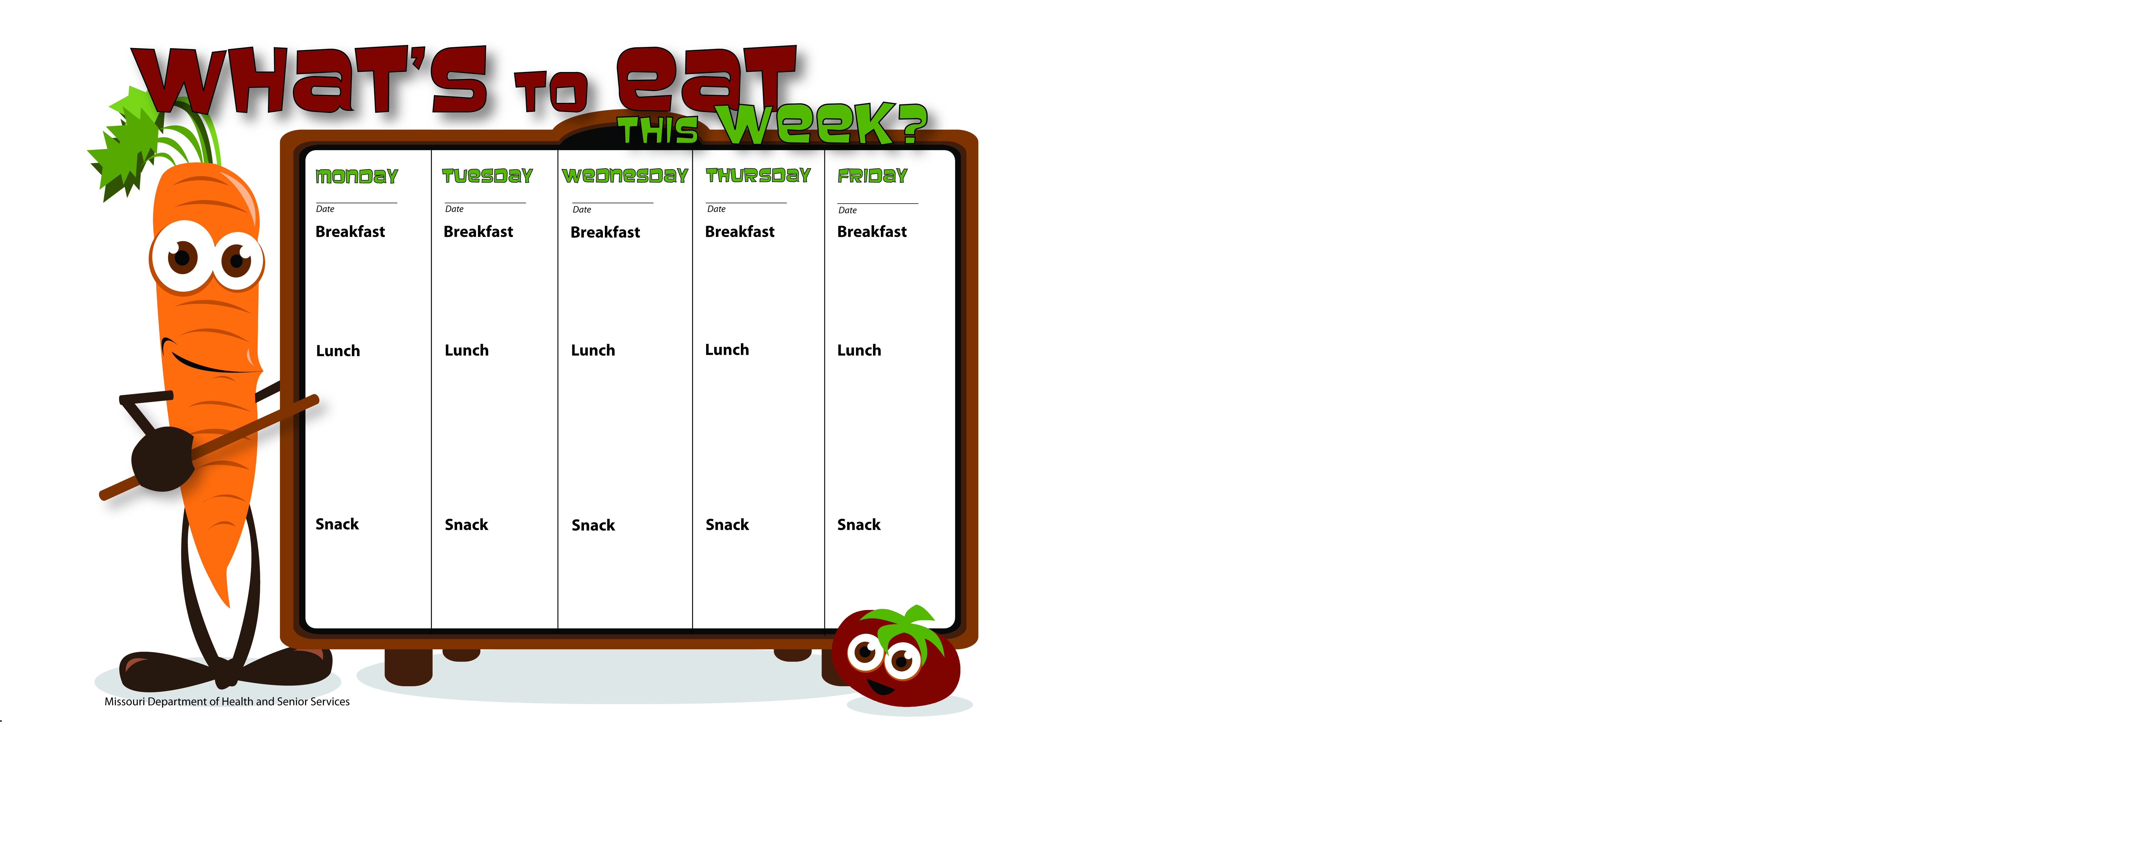

4-6-15

4-7-15

4-10-15

4-9-15

4-8-15

Pretzel Stix

Peanut Butter

Skim Milk

Vanilla Yogurt

WG Cheerios

Water

Mostaccioli W/Ground Beef

Corn

Apple Slices

Skim Milk

WG Cheerios

Apple Slices

Skim Milk

Pancakes

Applesauce

Skim Milk

Blueberry Muffins

Peaches

Skim Milk

WG English Muffin W/Egg and Cheese

Pears

Skim Milk

WG Bagel Thin W/Peanut Butter

Apple Slices

Skim Milk

Spanish Rice W/Ground Turkey

Peas

Grapes

Skim Milk

Whole Wheat Ham Sandwich

Broccoli W/Ranch Dip

Bananas

Skim Milk

WG Chicken Alfredo Pizza W/Spinach

Mixed Vegetables

Mandarin Oranges

Skim Milk

WG Soft Taco W/Ground Beef, Lettuce

Orange Slices

Green Beans

Skim Milk

Carrot Stix

Ranch Dip

Skim Milk

Fruit Salad

Skim Milk

WG Peanut Butter Banana Pocket

Skim Milk