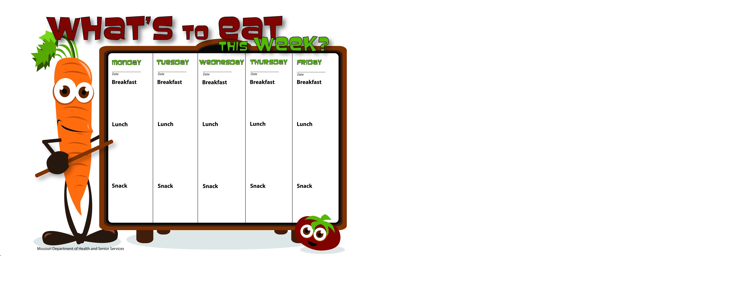

9-1-14

9-2-14

9-5-14

9-4-14

9-3-14

Animal Crackers

Peanut Butter

Skim Milk

Fruit Salad

Skim Milk

WG Beef and Noodles W/Ground Beef

Green Beans

Grapes

Skim Milk

CLOSED

LABOR DAY

Honey Nut Cheerios

Orange Slices

Skim Milk

Blueberry Muffins

Peaches

Skim Milk

WG Bagel Thin W/Egg and Cheese

Pears

Skim Milk

Pancakes

Applesauce

Skim Milk

WG Hot Ham and Cheese Wrap

Mixed Vegetables

Banana

Skim Milk

WG Chicken Burrito

Peas

Pears

Skim Milk

Vegetable Soup w/Ground Beef

Crackers

Apple Slices

Skim Milk

CLOSED

LABOR DAY

CLOSED

LABOR DAY

String Cheese

Wheat Crackers

Water

Carrot Stix

Ranch Dip

Skim Milk