C:\Users\Teresas computer\AppData\Local\Microsoft\Windows\Temporary Internet Files\Content.IE5\D1RAXFZ4\MC900355103[1].wmf

**HAPPY SPRING!**

**W**ell almost Spring. It’s in the air. Hope everyone has had a chance to get out and enjoy the weather. It won’t be long and everyday will be like this. Don’t forget the kids still need jackets and sometimes hats on more windy days. We try to get out for at least a few minutes each day.

**CPR CLASSES**

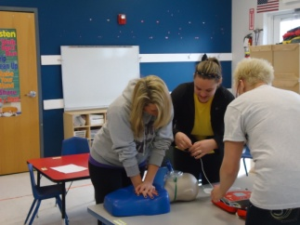

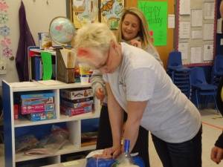

**I**t’s that time of year when we need to refresh our CPR skills. Seven of the staff participated in CPR classes on the 27th and 28th of February. Ms. Teresa, Ms. Jessica, Ms. Michelle, Ms. Debbie Starks, Ms. Sue, Ms. Lisa, and Ms. Randi all attended.

**Above:** Ms. Randi and Ms. Sue do chest compressions while Ms. Lisa operates the AED machine.

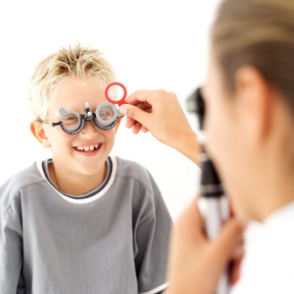

**FREE VISION SCREENINGS**

We are having our annual children’s vision screenings on Tuesday, March 20, here at All Aboard Learning Center. The screenings will begin at 9 am. We will be sending screening forms home with all children from 6 months through 5 years. If you are interested in having your child’s vision checked please read, complete and return the form before the 16th so we know how many will be screened. The screenings are done through the Missouri Lions Eye Research Foundation. The screenings require no physical contact with your child. For the infants and toddlers, your child’s teacher will hold them on her lap and a machine will scan their eyes. You will be notified of the results the day of the screening. You will receive further instructions if they detect any vision disorders.

C:\Users\Teresas computer\AppData\Local\Microsoft\Windows\Temporary Internet Files\Content.IE5\MI3Q8JTL\MC900310558[1].wmf

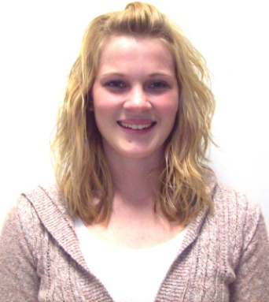

**WELCOME MS. SHANNON HEWKIN**

We have a new school age teacher, Ms. Shannon. She did her internship for college here at All Aboard and did a fabulous job. She is now employed at Cuba Elementary and is still a college student. She will be in school age on Tuesdays, Thursdays, and Fridays. Please welcome her to All Aboard!

C:\Users\Teresas computer\AppData\Local\Microsoft\Windows\Temporary Internet Files\Content.IE5\S0XLQ16R\MC900442036[1].wmf

**REMINDERS:**

* We collect Mace & Alps Receipts
* We collect Box Tops for Education
* Breakfast 7-8:15 (Please be here before 8:15)
* Please call by 9 to let us know if your child will not be here or if you’re running late
* Check parent grams every day for needed items for your child
* Make sure your child has extra clothing here, we don’t like calling parents at work.

C:\Users\Teresas computer\AppData\Local\Microsoft\Windows\Temporary Internet Files\Content.IE5\0E6TEMUA\MC900088588[1].wmf

**WHAT DOES ACCREDITATION MEAN FOR FAMILIES?**

Research shows that a higher level of quality in child care and educational settings is associated with children having enhanced social skills, reduced behavioral problems, increased cooperation and improved language skills.

Your children are provided with developmentally appropriate and sound program with suitable equipment and supplies and educated, well trained teachers, striving to provide children with the best experiences possible.

Your child will learn to interact with other children, be exposed to developmentally appropriate experiences, and most importantly acquire the tools to go out in the world and succeed!

C:\Users\Teresas computer\AppData\Local\Microsoft\Windows\Temporary Internet Files\Content.IE5\0E6TEMUA\MC900307559[1].wmf

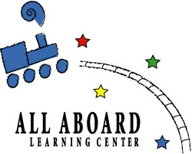

ALL ABOARD LEARNING CENTER

201 RUTZ SUBDIVISION ROAD

CUBA, MO., 65453

PHONE: (573) 677-2252

FAX: (573) 677-2273

[aalc@fidnet.com](mailto:aalc@fidnet.com)

allaboaardlearningcenter.org

**The center's mission is to provide a safe, structured and supportive program for the participating children; while at the same time, providing the opportunity for learning and functioning happily in an environment with others their own age.**

Missouri Accreditation Certified!

C:\Users\Teresas computer\AppData\Local\Microsoft\Windows\Temporary Internet Files\Content.IE5\D1RAXFZ4\MC900234181[1].wmf